WEEK 3 – PROCESS SCHEDULING SIMULATOR
Introduction
Process scheduling is an operating system function that decides which process gets CPU time. This project implements six scheduling algorithms in C and provides a menu-driven interface to test their behaviour.
Objectives
- Implement CPU scheduling algorithms in C.
- Accept arrival time, burst time and priority.
- Understand preemptive and non-preemptive scheduling.
- Evaluate scheduling performance using process metrics.
- Test algorithms using different datasets.
Tools Used
- Language: C
- Compiler: GCC
- Environment: Ubuntu Linux / WSL
- Interface: Command-Line Interface (CLI)
- Version Control: GitHub
Algorithms Implemented
- FCFS: Executes processes in arrival order.
- SJF Non-Preemptive: Selects the available process with the shortest burst time.
- SJF Preemptive: Selects the process with the shortest remaining time.
- Priority Non-Preemptive: Executes the highest-priority available process without interruption.
- Priority Preemptive: Allows a higher-priority process to interrupt the running process.
- Round Robin: Gives each ready process a fixed time quantum in turn.
Performance Metrics
- Turnaround Time (TAT) = Completion Time − Arrival Time
- Waiting Time (WT) = Turnaround Time − Burst Time
- Response Time (RT) = First Start Time − Arrival Time
- Average WT = Total WT / Number of Processes
- Average TAT = Total TAT / Number of Processes
- CPU Utilization (%) = (CPU Busy Time / Total Elapsed Time) × 100

Test Cases
Test Case 1
Process | Arrival | Burst | Priority
P1 | 0 | 5 | 2
P2 | 1 | 3 | 1
P3 | 2 | 4 | 3
Round Robin quantum: 2

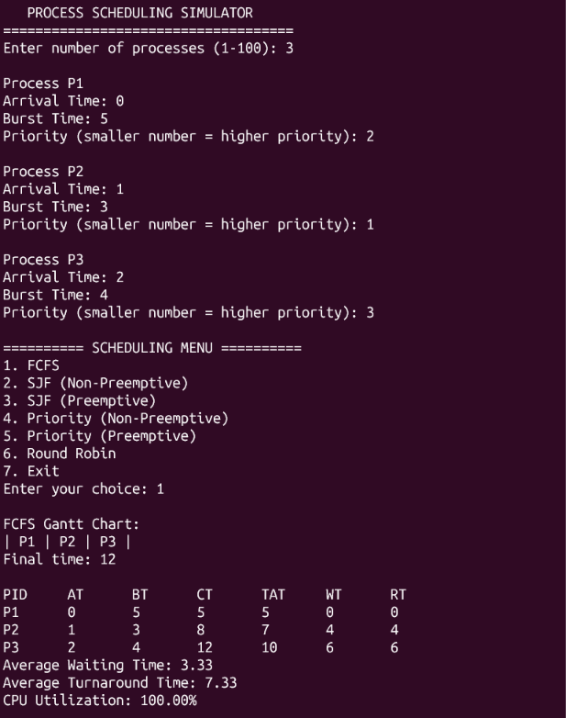
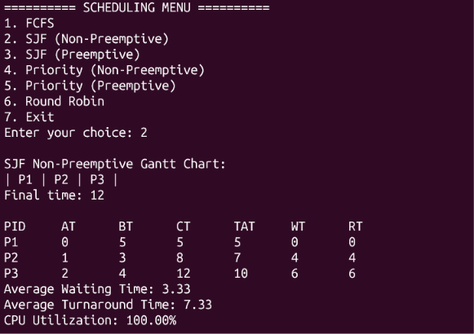

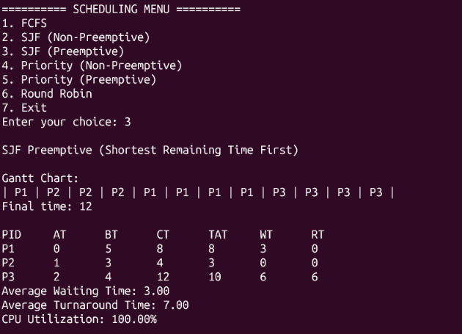

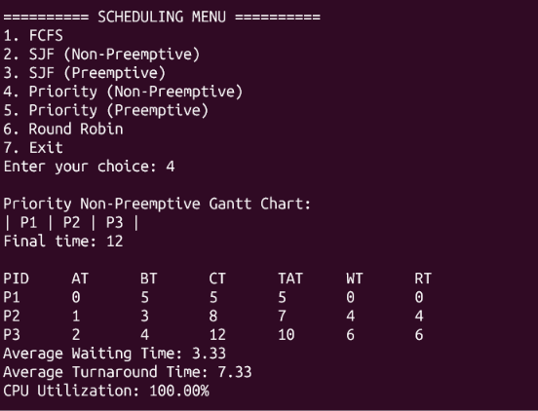

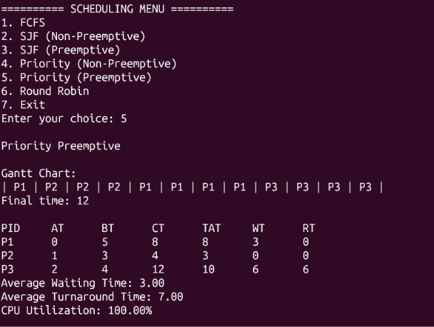

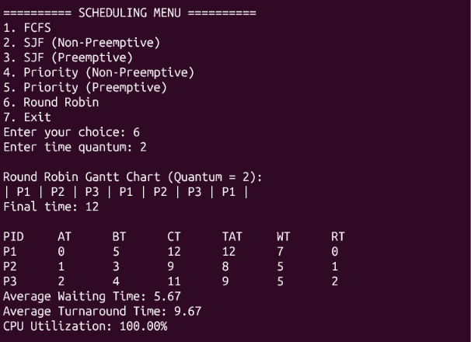
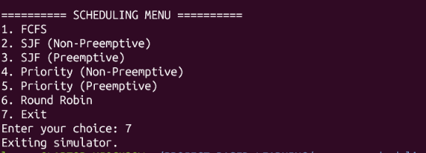

Test Case 2
Process | Arrival | Burst | Priority
P1 | 0 | 7 | 3
P2 | 2 | 4 | 1
P3 | 4 | 2 | 2
Round Robin quantum: 3

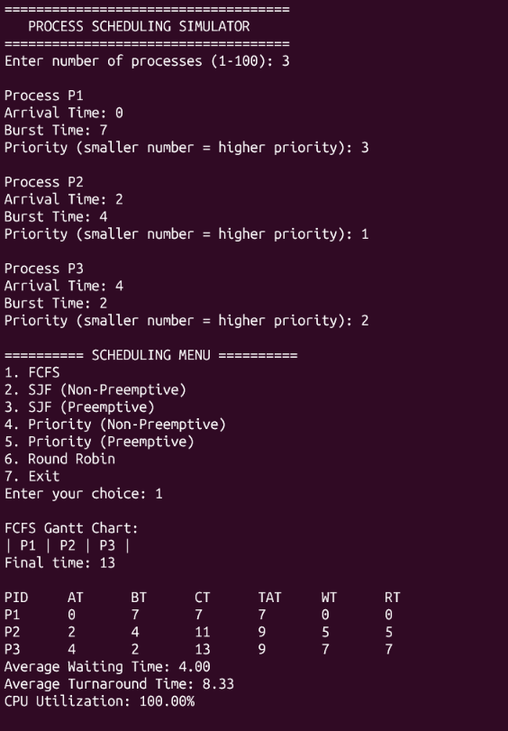

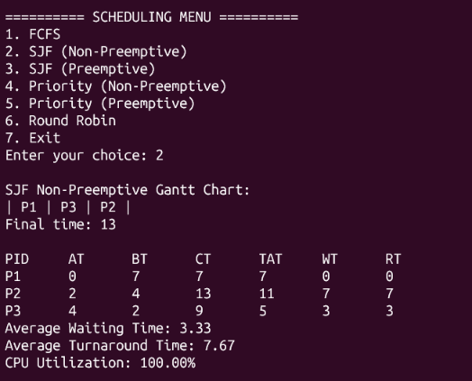

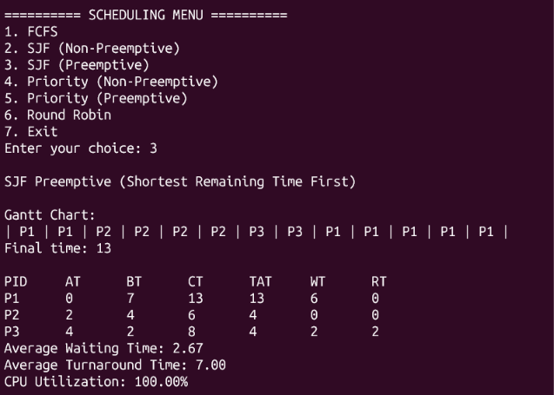

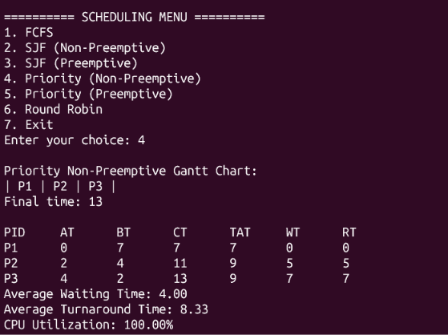

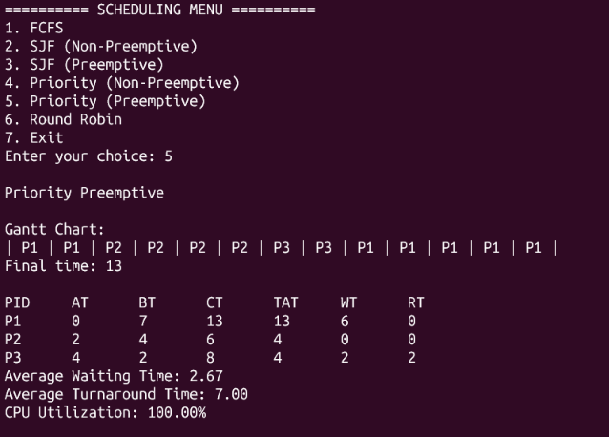

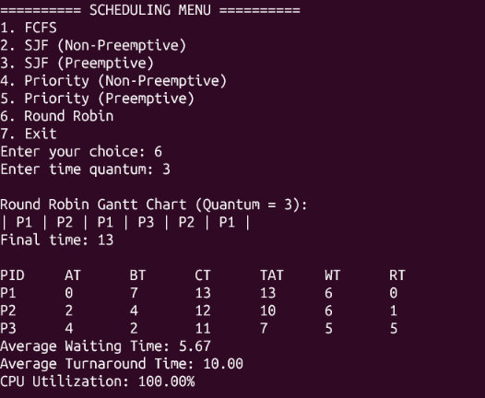

Test Case 3
Process | Arrival | Burst | Priority
P1 | 1 | 8 | 2
P2 | 0 | 3 | 1
P3 | 2 | 5 | 3
Round Robin quantum: 2

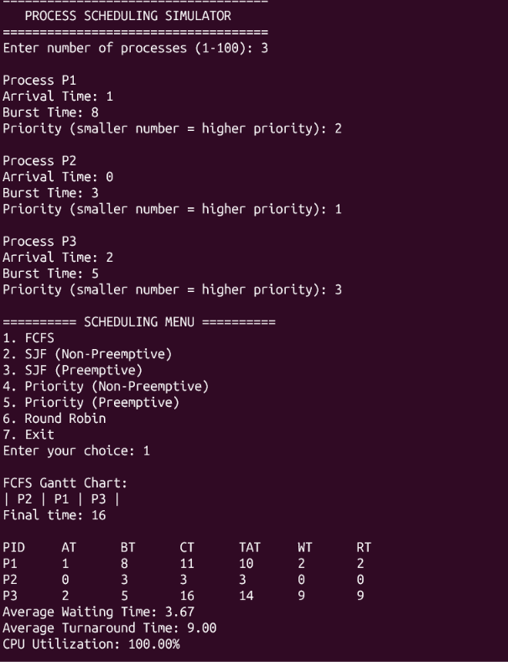
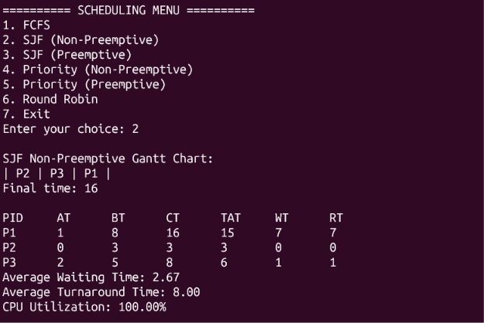

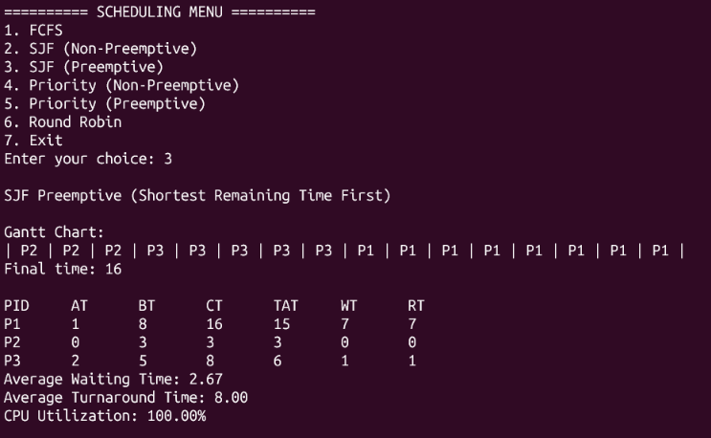

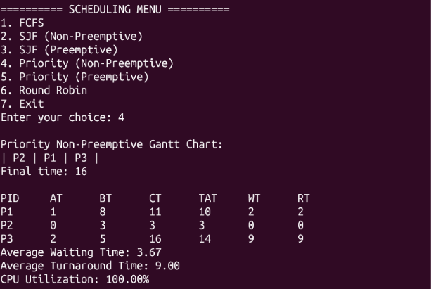

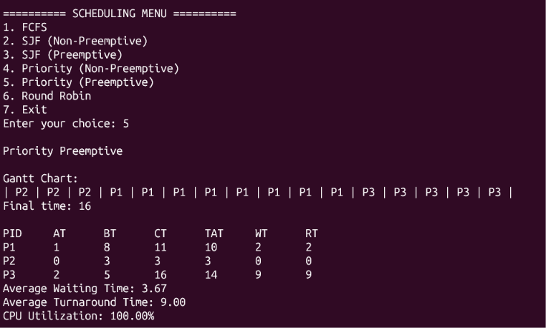

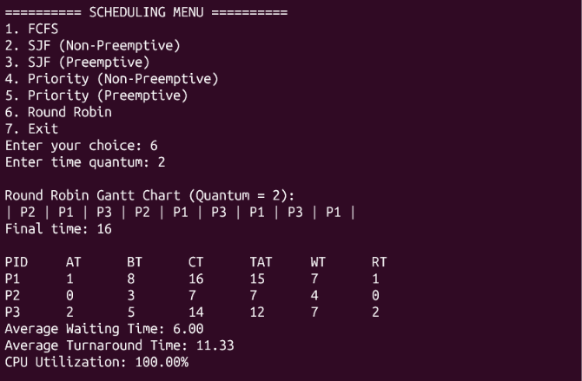

.
7. Performance Comparison
Test Case 1
Scheduling Algorithm | Average Waiting Time | Average Turnaround Time | CPU Utilization (%)
FCFS | 3.33 | 7.33 | 100.00
SJF Non-Preemptive | 3.33 | 7.33 | 100.00
SJF Preemptive | 3.00 | 7.00 | 100.00
Priority Non-Preemptive | 3.33 | 7.33 | 100.00
Priority Preemptive | 3.00 | 7.00 | 100.00
Round Robin (Q = 2) | 5.67 | 9.67 | 100.00

Test Case 2
Scheduling Algorithm | Average Waiting Time | Average Turnaround Time | CPU Utilization (%)
FCFS | 4.00 | 8.33 | 100.00
SJF Non-Preemptive | 3.33 | 7.67 | 100.00
SJF Preemptive | 2.67 | 7.00 | 100.00
Priority Non-Preemptive | 4.00 | 8.33 | 100.00
Priority Preemptive | 2.67 | 7.00 | 100.00
Round Robin (Q = 3) | 5.67 | 10.00 | 100.00

Test Case 3
Scheduling Algorithm | Average Waiting Time | Average Turnaround Time | CPU Utilization (%)
FCFS | 3.67 | 9.00 | 100.00
SJF Non-Preemptive | 2.67 | 8.00 | 100.00
SJF Preemptive | 2.67 | 8.00 | 100.00
Priority Non-Preemptive | 3.67 | 9.00 | 100.00
Priority Preemptive | 3.67 | 9.00 | 100.00
Round Robin (Q = 2) | 6.00 | 11.33 | 100.00

8. Conclusion
The Process Scheduling Simulator demonstrates six CPU scheduling algorithms using C. It allows users to enter process details and select an algorithm through a menu. Testing with different datasets helps explain how scheduling methods affect process execution and performance.

